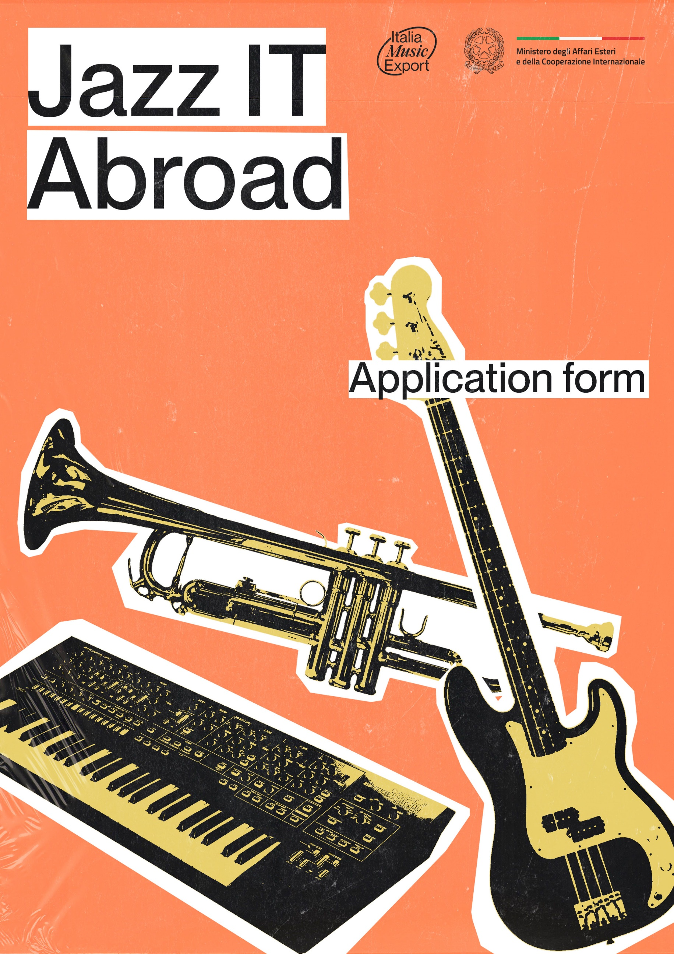

- WHO IS SUBMITTING THE PROJECT?
Fill in only one of the two following options (A or B):

A) THE APPLICANT IS A COMPANY ACTIVE IN THE MUSICAL SECTOR
(management, booking, press office, event organisation, production, publishing or record distribution)
Name
Date of establishment
Legal form
Registered office
Fiscal code/VAT number
Tel.
Email
Website
Social network

Name and surname of the legal representative (Note: in the case of an application submitted by an organisation active in the field of music on behalf of a minor, a valid document of the legal representative of the organisation active in the field of music, the minor's parent, legal guardian or curator must be attached. The application form must also be signed by the parent exercising parental authority, by the guardian, or by the person himself/herself with the assistance of the curator).

B) THE APPLICANT IS THE ARTIST HIMSELF/HERSELF
(In the case of a band, the band may choose one of its members as the submitting party, who shall comply with the rules outlined in section 4 of Jazz IT Abroad and any other applicable rules and regulations of Jazz IT Abroad)

First name (Note: if the applicant is a minor or subject to guardianship or curatorship, the declarations and documents required by the regulations must be signed by the parent exercising parental authority, the legal guardian, or by the applicant himself/herself with the assistance of the curator, and a valid identity document of the parent, guardian or curator must be attached to the application form) __________________________
Last name __________________________
Role (if a member of a band) __________________________
Nationality __________________________
Residence _________________________________________________________
Fiscal Code __________________________
Email __________________________ Phone __________________________
Role (if member of a band - also indicate if you are the leader)__________________________ Nationality (of each member and the leader)
___________________________________________________________________________________________________________________________________________________________________________________________________________________________________
Residence (of each member and the leader)
_____________________________________________________________________________________________________________________________________________________________________________________________________
VAT number _________________________ (fill in only if in possession)
If you have a VAT number, please indicate whether you are registered for VAT:
- ordinary
- flat-rate (ex Law 190/2014 and subsequent amendments)
indicate whether under a scheme allowing VAT deductibility:
- deductible VAT
- non-deductible VAT
E-mail
Phone __________________________

- APPLICANT’S PRESENTATION
Introduce the musical entity proposing the project, including any tours organised or record productions promoted, produced or edited in the last 2 years (do not use more than 300 words).
Do not fill in if the applicant is the artist himself/herself
_________________________________________________________________________________________________________________________________________________________________________________________________________________________________________________________________________________________________________________________________________________________________________________________________________________________________________________________________________________________________________________________________________________________________________________________________________________________________________________________________________________________________________________________________________________________________________________________________________________________________________________________________________________________________________________________________________________________________________________________________________________________________________________________________________________________________________________________________________________________________________________________________________________________________________________________________________________________________________________________________________________________________________________________________________________________________________________________________________________________________________________________________________________________________________

Italian artists represented
Do not fill in if the applicant is the artist himself/herself
____________________________________________________________________________________________________________________________________________________________________________________________________________________________________________________________________________________________________________________________________________________________________

TOURS ORGANISED OR PROMOTED IN 2019-2021 (if applicable)
Do not fill in if the applicant is the artist himself/herself
- Artist ___________________ Year ________ Number of concerts performed ___________
Countries where concerts took place __________________________
- Artist ___________________ Year ________ Number of concerts performed ___________
Countries where concerts took place __________________________
- Artist ___________________ Year ________ Number of concerts performed ___________
Countries where concerts took place __________________________

DISCOGRAPHIC PRODUCTIONS PRODUCED/EDITED IN 2019-2022 (if applicable)
Do not fill in if the applicant is the artist himself/herself
- Artist ___________________ Title ___________________ Year _______
Label/Publisher __________________
Publication country _________________________
- Artist ___________________ Title ___________________ Year _______
Label/Publisher __________________
Publication country _________________________
- Artist ___________________ Title ___________________ Year _______
Label/Publisher __________________
Publication country _________________________

3. ARTIST/BAND’S PRESENTATION

Name __________________________

ARTIST/BAND DATA
(fill in as many lines as the number of musicians who will perform during the concerts)
- Name __________________________ Last Name __________________________
Role _________________________________________________
- Name __________________________ Last Name __________________________
Role _________________________________________________
- Name __________________________ Last Name __________________________
Role _________________________________________________
- Name __________________________ Last Name __________________________
Role _________________________________________________
- Name __________________________ Last Name __________________________
Role _________________________________________________
ARTIST/BAND’S BIOGRAPHY (do not use more than 300 words)
If the artist has not yet developed experience abroad, please indicate the strategic export plan for the future (please be careful not to include any particular personal data revealing the political, religious or sexual orientation of the person concerned)
_________________________________________________________________________________________________________________________________________________________________________________________________________________________________________________________________________________________________________________________________________________________________________________________________________________________________________________________________________________________________________________________________________________________________________________________________________________________________________________________________________________________________________________________________________________________________________________________________________________________________

ARTIST/BAND’S DISCOGRAPHY
(fill in as many lines as the number of albums or ep published till now, if any)
- Title ______________________ Publication year _______
Label/Publisher __________________ Publication country _________________________
- Title ______________________ Publication year _______
Label/Publisher __________________ Publication country _________________________
- Title ______________________ Publication year _______
Label/Publisher __________________ Publication country _________________________
Website __________________________
Social Network __________________________
Spotify/Bandcamp/Soundcloud/Youtube Url (max two accounts)
________________________________________________________________________________
________________________________________________________________________________
Management Italy _____________________ Abroad _______________________
Booking Agency Italy __________________ Abroad ______________________
Press Office Italy ____________________ Abroad _____________________
Label Italy _________________________ Abroad _____________________
Publisher Italy __________________________ Abroad _____________________
CONCERTS WITHIN 2018–2022 (n.) Italy _______ Abroad _______

4. PRESENTATION OF THIRD PARTIES INVOLVED IN THE PROJECT (ITALIAN OR FOREIGN)
(Please indicate any ongoing collaborations related to the concerts abroad you are applying for, i.e promoter, booking agency, press office, festivals.
Add additional fields if there are more than two collaborations, do not use more than 100 words per field)
- Name ___________________ Website_______________________
Nationality (head office) ________________________________
Activities performed (e.g. booking agency, press office, other)
__________________________________________________________________________
Company/freelance presentation (use no more than 100 words)

______________________________________________________________________________________________________________________________________________________________________________________________________________________________________________________________________________________________________________________________________________________________________________________________________________________________________________________________________________________________________________________________________________________

Collaboration methods within the project (do not use more than 100 words)
____________________________________________________________________________________________________________________________________________________________________________________________________________________________________________________________________________________________________________________________________________________________________________________________________________________________________

2. Name ___________________ Website _______________________
Nationality (head office) ________________________________
Activities performed (e.g. booking agency, press office, other)
_________________________________________________________________________
Company/freelance presentation (use no more than 100 words) ______________________________________________________________________________________________________________________________________________________________________________________________________________________________________________________________________________________________________________________________________________________________________________________________________________________________________________________________________________________________________________________________________________________

Collaboration methods within the project (do not use more than 100 words)

__________________________________________________________________________

5. ACTIVITY PROJECT
Please note: under penalty of exclusion, the application must be accompanied by proof of actual confirmation of the concerts or tour for which the grant is requested: invitation letter filled in and signed by the promoter(s) (template available on the last page of this application form). If you already have a signed contract, please attach that too.

TOTAL NUMBER OF SCHEDULED DATES _____

LIST OF SCHEDULED DATES
(Add more fields if there are more than 10 dates
- City ______________________ Country ______________________ Venue _______________________ Date ___________________ Local Promoter _______________________________________
- City ______________________ Country ______________________ Venue _______________________ Date ___________________ Local Promoter _______________________________________
- City ______________________ Country ______________________ Venue _______________________ Date ___________________ Local Promoter _______________________________________
- City ______________________ Country ______________________ Venue _______________________ Date ___________________ Local Promoter _______________________________________
- City ______________________ Country ______________________ Venue _______________________ Date ___________________ Local Promoter _______________________________________
- City ______________________ Country ______________________ Venue _______________________ Date ___________________ Local Promoter _______________________________________
- City ______________________ Country ______________________ Venue _______________________ Date ___________________ Local Promoter _______________________________________
- City ______________________ Country ______________________ Venue _______________________ Date ___________________ Local Promoter _______________________________________
- City ______________________ Country ______________________ Venue _______________________ Date ___________________ Local Promoter _______________________________________
- City ______________________ Country ______________________ Venue _______________________ Date ___________________ Local Promoter _______________________________________
- City ______________________ Country ______________________ Venue _______________________ Date ___________________ Local Promoter _______________________________________

WILL A TECHNICAL SUPPORT FIGURE ACCOMPANY THE ARTIST/BAND?
(manager, label manager, booking agent, press officer, tour manager or sound engineer)
YES ☐ / NO ☐

If yes, specify who
________________________________________________________________________________

MEANS OF TRANSPORT THAT WILL BE USED ______________________

REPERTOIRE THAT WILL BE PERFORMED
(Indicate song titles and relevant ISWC codes)
________________________________________________________________________________________________________________________________________________________________________________________________________________________________________________________________________________________________________________________________________________________________________________________________________________________________________________________________________________________________________________________________________________________________________________

CONCERTS OBJECTIVES AND EXPECTED RESULTS
(Describe the expected results of the concerts abroad. Considering the artist's past and future career abroad, what are the concrete objectives in terms of promotion, audience growth, contacts and new collaborations? Justify your choice using a maximum of 300 words).
________________________________________________________________________________________________________________________________________________________________________________________________________________________________________________________________________________________________________________________________________________________________________________________________________________________________________________________________________________________________________________________________________________________________________________________________________________________________________________________________________________________________________________________________________________________________________________________________________________________________________________________________________________________________________________
________________________________________________________________________________________________________________________________________________________________________________________________________________________________________________________________________________________________________________________________________________________________________________________________________________________________________________________________________________________________
________________________________________________________________________________
________________________________________________________________________________________________________________________________________________________________________________________________________________________________________________________________________________________________________________________________________________________________________________________________________________________________________________________________________________________________
________________________________________________________________________________________________________________________________________________________________________________________________________________________________________________

6. COMMUNICATION AND PROMOTION PROJECT

Type of communication and promotion means to be adopted and their planning
__________________________________________________________________________________________________________________________________________________________________________________
_____________________________________________________________________________________________________________________________________________________________________________________________________________________________________________________________________________________________________________________________________________________________________________________________________________________________________________________________

Press office supporting the concerts
________________________________________________________________________________________________________________________________________________________________________________________________________________________________________________________________________________________________________________________________

Web marketing, social media marketing and related planning
________________________________________________________________________________________________________________________________________________________________________________________________________________________________________________________________________________________________________________________________
OTHER Promotional material (specify formats) and related distribution plan
________________________________________________________________________________________________________________________________________________________________________________________________________________________________________________________________________________________________________________________________________________________________________________________________________________

PLEASE NOTE: Under penalty of exclusion, the winning artists (assignees) must cite and/or include the logo of Italia Music Export and the logo of the Ministry of Foreign Affairs and International Cooperation, prior approval of the institutions, in the content related to the promotion of the project and in the posts that will be published on social networks regarding the concerts subject to grant, without subsequently archiving and/or deleting them.

Failure to comply with this condition may lead to the cancellation of part or all of the grant.

7. PROJECT BUDGET
(add more lines if necessary)

A | LOGISTICAL EXPENSES | COST
A1 | Transport tickets (planes, trains, buses, ferries, ships) | €
A2 | Car rental or car sharing, van or minibus | €
A3 | Gasoline | €
A4 | Parking and motorway toll | €
 | TOTAL LOGISTICS EXPENSES | €

________________________________________________________________________________

B | ACCOMMODATION EXPENSES | COST
B1 | Number of people | €
B2 | Number of nights | €
 | TOTAL ACCOMMODATIONS EXPENSES | €

________________________________________________________________________________

C | MERCHANDISING EXPENSES | COST
C1 | Merchandising | €
C2 | Merchandising | €
 | TOTAL MERCHANDISING EXPENSES | €

________________________________________________________________________________

D | CUSTOMS EXPENSES | COST
D1 | Carnet A.T.A. | €
D2 | Visa | €
D3 | Legal agency fee | €
 | TOTAL CUSTOMS EXPENSES | €

E | PROMOTIONAL EXPENSES | COST
E1 | Web and social media marketing | €
E2 | Purchase of advertising space | €
E3 | Other | €
 | TOTAL CUSTOMS EXPENSES | €

TOTAL ELIGIBLE EXPENSES (A+B+C+D+E) € ___

BUDGET FORMULATION CRITERIA AND FURTHER DETAILS
(Explain here how you calculated the individual budget items in the previous budget)
________________________________________________________________________________________________________________________________________________________________________________________________________________________________________________________________________________________________________________________________________________________________________________________________________________________________________________________________________________________________________________________________________________________________________________________________________________________________________________________________________________________________________________________________________________

The Applicant requests a grant from Jazz IT Abroad of
EURO ________,00

PLEASE NOTE:
- For each project submitted, the maximum amount that may be requested is 10.000,00€

- The grant is intended as a non-repayable grant. The grant will be paid out upon completion of all the activities envisaged in the project
- Eligibility for the grant is subject to the remaining availability of the available budget
- For any other rules please read carefully the Rules and Regulations available at www.italiamusicexport.com

To this end, I hereby declare that I have not been convicted of any criminal offence, that I am not in a state of disqualification and that I am not the subject of any preventive measures or judicial orders entered in the criminal record, and that to the best of my knowledge I am not subject to criminal proceedings for any of the offences referred to in Article 416-bis of the Penal Code,
I DECLARE
- that the applicant corresponds to the beneficiary artist or to a company active in the music sector (management; booking; press office; event organisation; record production; record publishing; record distribution) with a VAT number and corresponding Ateco Code, which complies with the legislation on labour relations and the National Collective Labour Contracts in force in the sector in Italy;
- that the applicant has its registered office in Italy (if a legal entity) or is resident in Italy (if natural person);
- to comply with the purposes, contents and implementation modalities described in this form and all the articles of Jazz IT Abroad and in particular to possess all the participation requirements provided for in point 5 of the Regulation
- to be aware that Italia Music Export and Italia Music Lab may request the submission of documentation as proof of possession of the requirements and declarations made with this application form;
- to be aware that all data provided in the context of this procedure will be processed by Regulation (EU) 2016/679 on the General Data Protection Regulation (GDPR) and Legislative Decree 196/2003. The applicant is required to maintain the confidentiality of personal data and information, on whatever support contained and in whatever manner collected, acquired or processed in the implementation of the participation in Jazz IT Abroad, except those that constitute public information or are publicly known;
- to have read and understood the information notice under article 13 GDPR on the processing of Personal Data, carried out by Italia Music Lab, as Data Controller, published on the website www.italiamusicexport.com. Concerning the processing mentioned above of Personal Data and the comparative purposes, the applicant declares to be aware that in case of failure/partial/ineffective provision of personal data he/she will not be able to participate in Jazz IT Abroad. Furthermore, the applicant declares that he/she has been informed that he/she may exercise his/her rights under articles 15-22 GDPR by writing to info@italiamusiclab.com and may, in any case, refer to the Italian Data Protection Authority;
- that there are no situations of potential conflict of interest between the undersigned and the Foundation, nor pending litigation of any nature with the same;
- that the declarant has no criminal convictions, is not in a state of disqualification and is not subject to preventive measures or other measures.

ATTACHED

- the calendar of confirmed concerts provided by the booking agency, a confirmation email from the promoter or venue, or a signed contract. This proof of confirmation must include the name of the artist or band, the date of the concert, the city, the venue and the capacity of the room.

- Certificate of VAT number including Ateco code (not applicable if the applicant is the artist himself/herself);
- Valid Chamber of Commerce certificate for entities registered in the Companies' Register or Memorandum and Articles of Association of the organisation certifying the performance of activities in the music sector as indicated in point 6 of the Call Promo 2021 (not applicable if the applicant is the artist himself/herself)

- Copy of a valid identity document of the Legal Representative of the applicant or the artist himself/herself in case he/she is the same artist as the applicant

GENERAL CONDITIONS, DISCLAIMER OF USE
The Jazz IT Abroad regulation does not constitute an offer to the public, nor does it entail for Italia Music Export and for the Ministry of Foreign Affairs and International Cooperation any obligation or constraint towards the participants, nor does it assign to the latter any right to any performance or disbursement by Italia Music Export itself. Similarly, Italia Music Export reserves the right to interrupt, revoke or abandon at any time the activity inherent to the present regulation according to its full discretion, without any constraint or limitation and any claim for compensation or reimbursement by any of the participants.
Each participant in the procedure will therefore bear its expenses - including those concerning the formation and submission of the bid-withoutItalia Music Lab and the Ministry of Foreign Affairs and International Cooperation being liable in any way for said expenses.
By participating in Jazz IT Abroad, applicants authorise Italia Music Lab and Italia Music Export to publish on their website a brief description and/or documents submitted for participation and/or to promote the projects submitted to the public in other forms and ways. The materials submitted for participation may be used by Italia Music Lab and Italia Music Export as part of their communication activities through the publication of content on their website, on their social platforms and other communication channels via the internet, radio, press and television. It is understood that the release for use of the application form and/or documents submitted to participate in Jazz IT Abroad is granted by the applicants free of charge, without any territorial limitation or frequency of use, in whole or in part, individually or together with other material, including, without any limitation, texts, photographs or images, in any format, on the internet and radio, press and television, for three (3) years from the announcement of the winners, to allow Italia Music Lab and Italia Music Export to promote the individual initiatives to the public and to disseminate the results of Jazz IT Abroad. All personal data provided by the participants through the applicant in the context of this call for proposals will be processed in compliance with Regulation (EU) 2016/679 on the General Data Protection Regulation (GDPR) and D. L.vo 196/2013. The applicant is required to maintain the confidentiality of documents, data and information, on whatever medium contained and by whatever means collected, acquired or processed in the implementation of the project, except for those that constitute public information or are in the public domain, i.e. publicly knowable.

Place and date Applicant signature
___________ __________________

INVITATION LETTER

(In case of more than one concert, please add each of them below)

ARTIST:

CONCERT DATE:
CITY:
VENUE:
CAPACITY:
ADDRESS:
WEBSITE:

ARTIST:

CONCERT DATE:
CITY:
VENUE:
CAPACITY:
ADDRESS:
WEBSITE:

PAID BY THE PROMOTER:

- ________ (e.g. backline, travels, accommodation)
- ________
- ________

PROMOTER CONTACT:

Company name:
Registered office:
VAT no:
Legal representative:
e-mail:
Telephone:

The promoter declares his/her intention to invite the artist ___________ to play at the above-mentioned venue(s) and date(s).

Date: Signature
_______________ ____________________

